**EXPLORING THE HETEROGENEITY** **INSIDE POPULATION**

**TO ENHANCE CROWD MODELLING OF GROUP DYNAMICS**

1. **Introduction**

Rapid urbanization and population growth are always inevitable challenges for every country in the effort of planning infrastructure, estimating traffic needs and capacities, and increasing the safety of pedestrians since over 70% of the world population is predicted to live in cities by 2050 (Weidmann, 2012). With the increase in the number of public events and the number of accidents during these events (Evers, 2011), the demand of realistic crowd simulation models becomes important for risk management in urban design and crowd safety. To make an effort for creating realistic simulation models, various studies aims to understand and simulate behaviours which can unfold in both normal and emergency situations such as group of pedestrians moving or competing each together.

In fact, a real group are heterogeneous. In normal situations, a group may contain different pedestrians in demographic traits in places such as shopping mall, sport stadium. By analysing disasters happened, (Aguirre, 2011) found that a pedestrian may select another pedestrian based on demographic traits to move together.

Group cohesion behaviour is observed by its cohesion degree and formation. Cohesion degree performs the average distance to group’s centre of mass from each group members. Observable human group formations are V-like, line-abreast, or river-like (Moussaid, 2010). Group members are in different positions of each formation.

Various models have been proposed to simulate how pedestrians move to maintain group cohesion such as social-force based model, cellular automata model, and agent-based models. However, current group simulation models either makes assumption that populations are homogeneous or do not validate the impact of agent’s parameters on group cohesion behaviour when group moves through a door. Therefore, this PhD study aims to explore the effects of group cohesion behaviour by varying group member’s parameters based on social group force model. Finally, the observation of actual groups in which group members are different in age is performed to validate the effect of group cohesion behaviour.

This proposed research aims to help event organizers restore the order of crowd before deteriorative situations can occur when a crowd of groups is trying to escape a narrow door in live events.

1. **Literature Review**

This section reviews models which simulate group dynamics. The range of models varies from modelling investigating force affecting to each pedestrian inspided by fluid dynamics, until devide cell, or define rules of follows.

**2.1. Social force model for group behaviour**

Moussaid, Helbing and colleagues (Moussaid, 2010) created the social group model based on the social-force model. The model represents that a pedestrian *p* at time *t* is trying to move with a certain desired speed $v_{p}^{d}(t)$ in a desired direction $\vec{e_{p}^{d}}(t)$ pointing from pedestrian *p*’s current position to his target position. Therefore, pedestrian *p* tends to correspondingly adapt his actual velocity ${\vec{v}}_{p}(t)$ with a certain acceleration time $τ_{p}$. The acceleration time represents pedestrian *p* changes its current velocity and return to its desired velocity. Pedestrian *p*’s acceleration at time *t* also depends on repulsive forces coming from surrounding pedestrians and obstacles. The repulsive force’s directions are represented in Figure 1. Group influence force $\vec{f_{p}^{group}}\left(t\right)$ aims to describe that an individual in group continuously adjusts its position to reduce its head direction and maintain group’s centre of mass, but also avoid group members each other as in equations. The model’s formula is represented in equations (1-3)

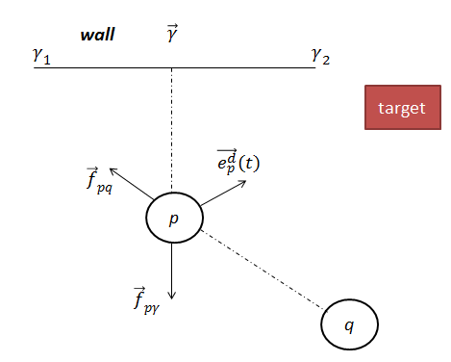

**Fig 1**. Repulsive forces ${\vec{f}}_{pq}$ and ${\vec{f}}_{pγ}$ on pedestrian *p* created by pedestrian *q* and wall γ. A group force created by pedestrian *k*

|  |  |
| --- | --- |
| $$\frac{d\vec{v_{p}}(t)}{dt}=\vec{f_{p}}\left(t\right)+ ξ_{p}(t)$$ | (1) |
| $\vec{f_{p}}(t)$ = $\frac{1}{τ_{p}}\left(v_{p}^{d}\left(t\right)\vec{e_{p}^{d}}\left(t\right)-\vec{v_{p}}\left(t\right)\right)+\sum_{q(≠p)}{{\vec{f}}_{pq}\left(t\right)+ \sum_{γ}{{\vec{f}}_{pγ}\left(t\right)+ \vec{f_{p}^{group}}\left(t\right)}}$ | (2) |
| $$\vec{f_{p}^{group}}\left(t\right)= \vec{f_{p}^{vis}}\left(t\right)+ \vec{f_{p}^{att}}\left(t\right)+ \vec{f_{p}^{rep}}\left(t\right)$$ | (3) |

where $v_{p}^{d}\left(t\right)$ is desired speed of pedestrian *p* and varies over time. Fpvis, fpatt, frep,…

//Group formation V, inverse when change parameters, b =

Parameters

//picture of 3 group format

To summary, the social force model comprises parameters that need to be set at initial simulation time as in Table 1:

|  |  |  |
| --- | --- | --- |
| **Parameter** | **Component** | **Description** |
| $$V_{p}^{Id}$$ | Desired Acceleration | Initial desired velocity |
| $$τ_{p}$$ | Desired Acceleration | Acceleration time to reach desired speed |
| $$c$$ | Desired Acceleration | Constant to find maximum velocity |
| $$λ$$ | Interaction Force | Angular component |
| *A* | Interaction Force | Interaction strength |
| *B* | Interaction Force | Interaction range based on distance between *p*, *q* |
| U | Obstacle Force | Obstacle interaction strength |
| $${ R}_{p}$$ | Simulation | Radii of pedestrian *p* in simulation environment |
|  | Group force |  |
|  | Group force |  |
|  | Group force |  |

However , this model is cristizied by, …. To simulate group cohesion behaviour, at different pedestrian-oriented places (e.g sport stadium, high schools, working places) in recent studies (Leeson, 2014) and another Naturetechnical report (Gosce, 2014). It is also explained that the earliest models including Reynold’s model (Reynolds,1987) and Social Force model (Helbing & Molnar,1995) averaged out potential influences to produce smooth flow of pedestrian movement (Collin, 2014)

* 1. **Cellular Automata model for group behaviour**

CA, vizzari, and in survey. Floor field, static field, obstacle field, Formulate of group cohesion and dispersion, group formation. A cell, pedestrian can move several cells.

**2.3. Agent-based model for group behaviour**

In agent-based model, (Pelechino, 2006) constructed a simulation environment and created different pedestrian roles (leader, untrained leader, group members) through agent-based model to simulate evacuation scenarios. (Aguirre, 2011) construct a simulation environment of and compared the difference in escape numbers of several prototypes constructed on agent-based model. The prototypes include individual behaviour, intermediate group (revert to individual behaviour while in duress), full group behaviour (follow group leader). The escape numbers are compared with actual survivor number. On social aspect, the author mentioned that a group leader can be selected by other through demographic traits such as age, gender and familiarity with environment. A group member follows leader if they are in the leader’s line of sight.

Another study to see group formation

1. **Research Questions**

According to a recent calibration study (Hoorgedoorn, 2012), it found that pedestrians different in age groups (children: <14 years old, adults, elders > 60 years old) are different in parameter distribution (speed, interaction strength). Thus, a group of different group members in demographic traits has different parameter distributions.

While force-based model and cellular automata model make assumption that populations are homogeneous and well-mixed, which is not true for real population,

one of the clearest limitations mentioned in the future work of the study (Weijmen, 2013) is the lack of a standard mechanism to measure the effects of agent’s parameters in the pedestrian’s force calculation. Moreover, the effect of cohesion group when group moving through coordiors has not been explored.

Move irraotionally unwanted to maintain group cohesion; thus, become obstacles for other pedestrians .Same size, if ped has diff value pamarame, different cohsion value, format. In high-dense place, a group automatically converts into river-like format to minimize collision with other pedestrians. Since

This study only uses social-force models since it is higly recommend by Hoorgedon 2013 for simulating obstacle crowd phenomena… (). And various rules. Therefore, this study proposes follow questions to analyse the effect group behaviour when vary parameters of different agents in social force model and how it impact on escape rate:

1. What is the effect of group member’s parameters in group cohesion behaviour when group moves through a narrow door?

1.1. How to simulate group of different agents having different parameter distributions in social-force model?

1.2. Is group behaviour different when varying parameters of each pedestrian?

* 1. How group behaviour affect escape rate when varying parameters of each pedestrian?
  + Does group generate different formation?
  + Does group generate allow when interact with another group individually, split o group cohesion, dispersion?

1. How to validate that effect through real observation?
2. **Research methodology**

The questions can be formulated as Figure

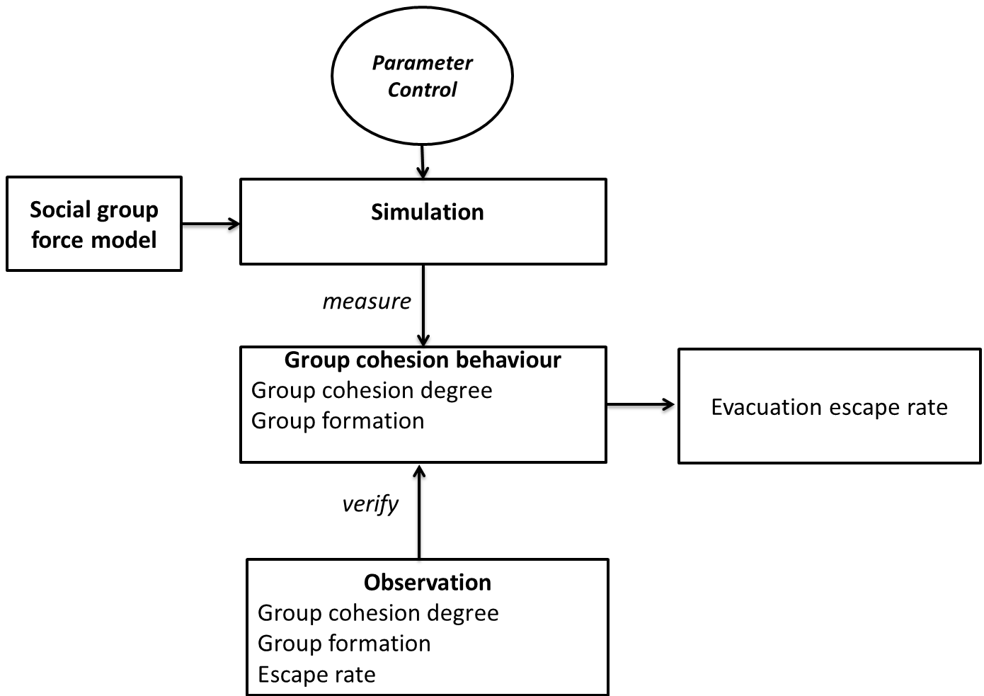

Recent, hoogedone found that equation (parameters less than) hypothesis: children > adult> elder velocity or low parameters, same group size, same percentiage of pedestrian inside crowd.

Is the difference in using same distribution for 3 members types, or different member types.

Developing this tool will allow us to easily customize initial parameters of each pedestrian and environment, and monitor expected information from crowd. Investigating what causes the difference in escape rate and blockage occurrences is then performed respectively on one and two dimensional simulations with simplified versions of social force model. It aims to understand the impact of possible reasons (e.g. parameter distribution, placements, velocities of pedestrians during simulation duration before phenomena occur).

p-children, different equation,

p-adult, different equation,

p=elderly, different equation,

Look at the relationship between group cohesion, and group dispersion degree? Group cohesion degree when various this parameter, t-test between centroid of this results when varying this parameter set of each group member type.

Look at possible group formation generate this difference from this parameter set?

Vary parameters for each pedestrian values.

Apply t-test and measure blockage, frequency, …

Show the format of N! depend on pedestrians,

Apply each parameter, generate for other as Helbing suggestion (Helbing, 2014). Generate Evoluton nary to measure escape rate, group cohesion degree.

Beta same, group cohesion same, escape rate different, (simulation then drag to stop and swap position to see the difference).

Q.2. How to verify this difference in escape rate by actual data?

Two groups are invited and move, a camera

Experiment 1: 9 ped, each group have 3 ped move group (different age) to infer that they have different physical information. Change a pair of 5 ped to infer different parameters of ped in group. They may change group formation when escape rate.

Experiment 2: 3 interact with another crow people move individually, who move individually., and vary size of another group to expect see more formation and cohesion defree

Compare escape rate with case study1.

**Table 1**- Data acquisition of group member and group information to infer group cohesion

|  |  |
| --- | --- |
| **Scope level** | **Acquired Data** |
| Group (meso level) | Percentage of pedestrian types in group  Total population size  Average speed at a certain time  Centre point of mass at a certain time |
| Individual (micro level) | Pedestrian type through hat colour  Pedestrian trajectory  Distance to other group members at a certain time  Distance to group’s centre of mass  Average speed over the time |
| Overal evacuation | Escape rate |

Table 1 represents required data to understand the effect of group cohesion towards different pedestrian inside group and other groups.

1. **Research progress**

Research simulation, blockage frequency

Research time line

1. **Coursework and professional development**

As required from our faculty, I completed the course FIT 5143 in the first semester 2015. I am attending the course FIT6021 from 31 July, 2015. I also completed 116 research training hours as in Table 3.

**Table 5**- List of professional development undertaken

|  |  |
| --- | --- |
| **Activity** | **Hours counted towards coursework goal** |
| Faculty Induction | 4 |
| Research Integrity | 12 |
| FIT 5143 Course | 48 |
| FIT 6021 |  |
| FIT 4012 | 15 |
| Monash Seminar/workshop attendance | 22 |
| Participation at Monash Bootcamp Commercialisation workshop in the year 2015 | 15 |

1. **References**

Aguirre, B. E., El-Tawil, S., Best, E., Gill, K., Fedorov, V., (2011) Contributions of social science agent-based models of building evacuation. *Contemporary Social Science: Journal of the Academy of Social Science*, Pages 415-432.

Almeida J. E., Rosaldo, R., Coelho, A. L., (2011) Crowd Simulation Modelling Applied to Emergency and Evacuation Simulations using Multi-Agent Systems. *In Proceedings of 6th Doctoral Symposium on Informatics Engineering*, DSIE.

Daamen, W., & Hoogendoorn, S. P.,2012. Calibration of pedestrian simulation model for emergency doors for different pedestrian types. *Transportation Research Record*, 2316, 69 - 75.

Evers, J. (2011) Modelling Crowd Dynamics: a Multiscale, Measure-theoretical Approach. *Master Thesis*. Eindhoven University of Technology, The Netherlands.

Gosce, L., Barton, D. A. W., Johansson, A., (2014) Analytical Modelling of the Spread of Disease in Confined and Crowded Spaces, *Nature Scientific Reports*, Vol. 4(4856).

Grosshandler, W., Bryner, N., Madrzykowski, Kuntz, K., (2005). Report of the Technical Investigation of the Station Nightclub fire. Technical report, *National Institute of Standards and Technology, USA*, 2005. Available at <http://fire.nist.gov/bfrlpubs/fire05/PDF/f05032.pdf>

Hoogendoorn, S.P., Duive, .D.C., Daamen, W., (December 2013). State-of-the-art crowd motion simulation models. *Transportation research part C*, Volume 37, Pages 193-209.

Hoogendoorn, S.P., Bovy, P. H.L (2003) Simulation of pedestrian flows by optimal control and differential games. *Optimal Control Applications and Methods*, Volume 24, Pages 153-172.

Helbing, D., Molnar, P., (1995) Social force model for pedestrian dynamics. *Physical Review E,* 51.

Helbing, D., Farkas, I., Vicsek, T., (2000). Simulating dynamical features of escape panic. *Nature*, Pages 4487-4490

Helbing, D., Balietti, S., (2011). How to Do Agent-Based Simulations in the Future: From Modeling Social Mechnisms to Emergent Phenomena and Interactive Systems Design.

Helbing, D., Mukerji, P., (2012). Crowd disaster as systemic Failures: Analysis of the Love Parade Disaster. *EPJ Data Science*, Volume 1(7).

Helbing, D., Brockmann, D., Chadefaux, T., Donnay, K., Blanke, U., Meza, O. W., Moussaid, M., Hohansson, A., Krause, J., Schutte, S., Perc, M., (2015) Journal of Statistical Physics, Vol. 158(3), pp 735-781.

Moussaid, M., Helbing, D., Garnier, S., Johansson, A., Combe, M., Theraulaz, G., (2009) Experimental study of the behavioural mechanism underlying self-organization in human crowds. *The proceeding of The royal society part B*.

Moussaid, M., Perozo, N., Garnier, S., Helbing, D., Theraulaz, G., (2010) The Walking Behaviour of Pedestrian Social Groups and Its Impacts on Crowd Dynamics. Plos One, Vol 5(4)

Moussaid, M., Theraulaz, G., (2012). Traffic Instabilities in Self-Organized Pedestrian Crowds. *PLos Computational Biology*.

Pelechano, 2006. Crowd Simulation Incorporating Agent Psychological Models, Roles and Communication. *In proceeding of 1st Workshop of Crowd Simulation*.

Reynolds, C., W., (1987), Flocks, herds and schools: A distributed behavioural model, New York, *NY: ACM*, 25-34.

Seer, S., Rudloff, C., Matyus, T., BBrandle, N., (2014). Validating social force based models with comprehensive real world motion data. *In proceedings of Pedestrian and Evacuation Dynamics, PED 2014*, pp 724-732.

Weidmann, U., Uwe, K., Schreckenberg, M. (eds). (2012) Pedestrian and Evacuation Dynamics 2012, *Springer*.

Wijermans*,* (2013). CROSS: Modelling Crowd Behaviour with Social-Cognitive Agents. *Journal of Artificial Societies and Social Simulation*.